**Project Report**

**Factory Data Analysis**

Name : **Disha Pravin Kolapkar**

Project Name : **Factory Data Analysis**

Date : 29-Oct-2024

Technology : PowerBI

**Project Description :**

* **Project Objectives:** Clearly state the specific goals of the analysis.
  + Identify machine performance and utilization.
  + Track order completion and shipment trends.

**Data Collection and Preparation :**

**·** To gain a comprehensive understanding of the factory data and identify key trends and patterns.

· To analyze customer behaviour and preferences to optimize sales strategies

· Identify and remove inconsistencies, errors, and outliers.

**Key Performance Indicators (KPIs):**

* + Material usage per unit of output
  + Machine utilization rate
  + Order fulfillment rate

**Objectives:**

1] **Data Collection & Preparation**:

· To gain a comprehensive understanding of the factory data and identify key trends and patterns.

· To analyze customer behaviour and preferences to optimize material strategies

· Identify and remove inconsistencies, prices, and quantity.

· Handle missing values appropriately (e.g., imputation, deletion).

2**] Data Transformation:**

· Convert data into a suitable format for Power BI (e.g., tabular).

· Create calculated columns and measures to derive new insights.

· Aggregate data to appropriate levels for visualization.

3] **Data Modeling:**

· Design a data model that accurately represents the relationships between tables and fields.

· Optimize the data model for performance and query efficiency.

4**] Visualization & Reporting:**

· Create visually appealing and engaging visualizations that convey insights effectively.

· Utilize a variety of chart types (e.g., bar charts, line charts, pie charts, donut) to suit different data types and analysis needs.

**Snapshots :**

**:**

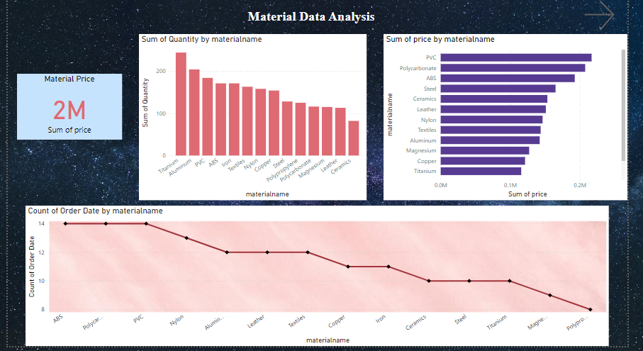

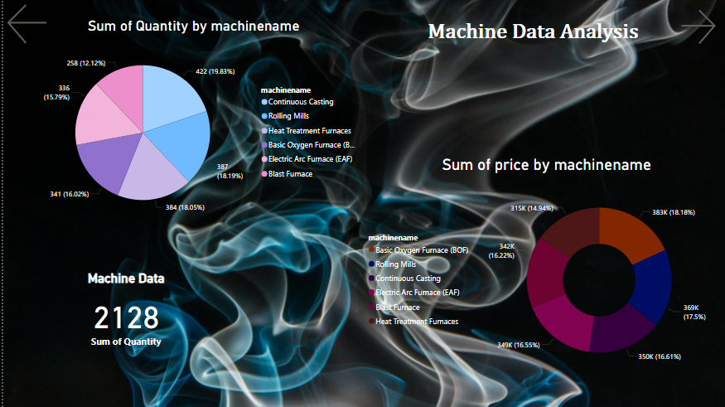

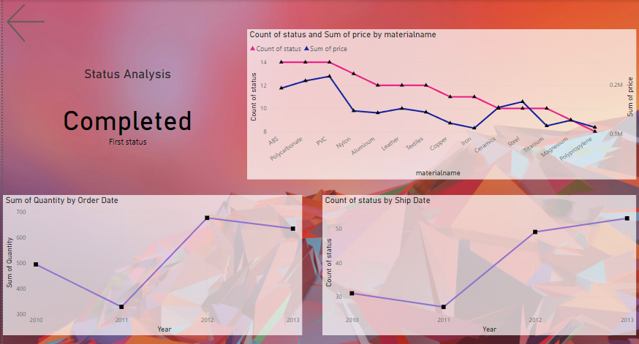

**Conclusion :**

The analysis of steel factory data using Power BI has provided valuable insights into various aspects of the production process, including material usage, machine performance, and order fulfilment. By implementing these recommendations, the steel factory can significantly enhance its operational efficiency, reduce costs, and improve customer satisfaction.